1

We are going to use the blood sample you collected at the crime scene. What needs tohappen before the blood sample can be used for PCR?

Selected option: DNA has to be isolated from the cells

For the PCR you need pure DNA, which l have already isolated for you. During this stepred blood cells were removed. That's why the sample is now colorless.

What is the function of primers in a PCR reaction? You can click on the VIEWTHEORY button to get some guidance with the question.

Selected option: Bind specific sites on the DNA

Primers will bind to regions of the DNA that match (are complementary to) their ownsequence, and their binding is a prerequisite for DNA copying by the DNA polymerase

For which enzyme are nucleotides the substrate?

Selected option: DNA polymerase

Nucleotides act as substrates for the DNA polymerase when creating new DNA strands.

What is the template of the PCR?

Selected option: DNA

DNA is the template for the PCR.

What does a DNA polymerase do?

Selected option: Synthesizes DNA

The DNA polymerase is responsible for synthesizing new DNA.

What do you need to do each time before using a pipette to collect liquid?

Selected option: Put on a new, sterile pipette tip

A new, sterile pipette tip should be used every time. lf you don't change the pipette tip,the experiment and the pipette can be ruined.

Why is it important to change the pipette tip?

Selected option: To avoid cross contamination

lf the pipette tip is not changed, you will end up contaminating both your own reaction andlab stock reagents

How did you collect liquid in the lab?

Selected option: Using a pipette

A pipette can be used to collect small and precise volumes.

At this step in the PCR process, what happens to the DNA?

Selected option: It will be separated into two strands

At this step the DNA denatures and becomes single stranded.

How is the DNA separated into single strands?

Selected option: The high temperature (95 °C)

At high temperatures the bonds between the two strands are destabilized.

What is the step in the PCR that is now shown called? You can click the VIEW IMAGEbutton to display the image in the LabPad.

Selected option: Annealing

In this step the primers anneal to the DNA.

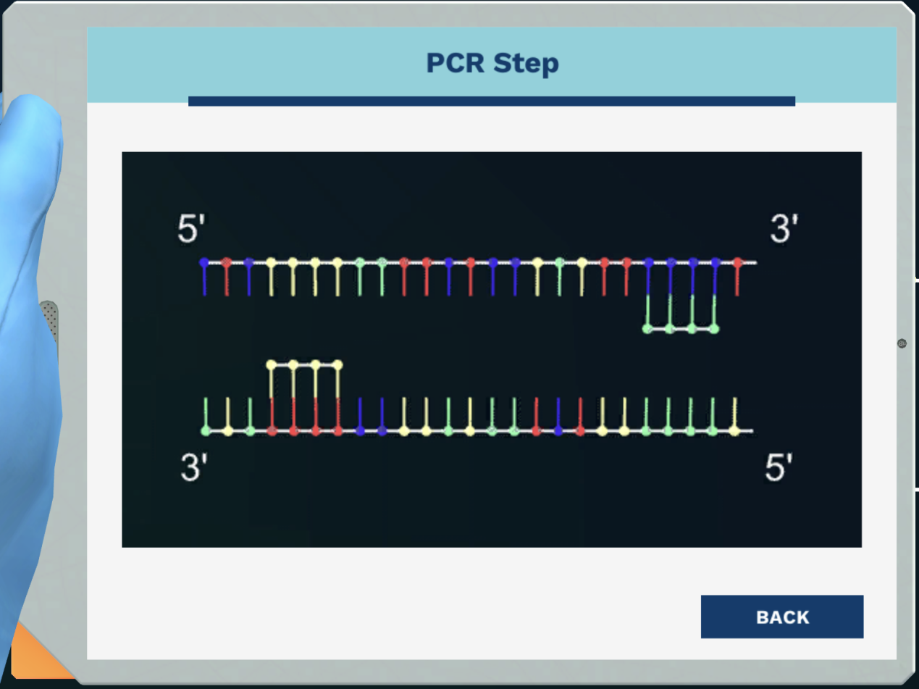

The area where the primers bind marks which part of the PCR product?

Selected option: Beginning, 5-end

The primers define the length of the PCR product. The area where the primer bindsmarks the beginning of the PCR product that is synthesized by the polymerase.

The PCR products get a certain length due to which fact?

Selected option: The placement of the primers

The placement of the primers defines the fragment length.

How does the DNA polymerase extend the primers into a new DNA strand?

Selected option: Adding nucleotides to the 3' end of the primers

The polymerase will add nucleotides to the 3' end of the primers.

Primers are always designed to be complementary to the template DNA strand. Which ofthese sequences is the complementary sequence to the template sequence

5'-GTGGTCTGATCAACGGTAA- 3'

Selected option:

3'-CACCAGACTAGTTGCCATT-5'

The sequence needs to be complementary, and the DNA direction (5'= 3'’) needs to bereversed(3’→ 5')

The number of repeats of each individual's tandem repeated regions can be diferentcreating a specific DNA profile. When using one primer pair in different individuals, whichphrase describes the PCR product?

Selected option: Different length may be found in each individual

You will have fragments of different lengths, since individuals might have differentnumbers of repeats creating their own specific DNA profiles

What happens to the probability of a 100% match between two different individuals whenusing 13 sets of primers for the DNA profile instead of one?

Selected option: It decreases

With an increase in the number of variable regions targeted, the probability of getting a100% match between two different people will decrease.

How many copies of DNA are required to see bands on the electrophoresis gel?

Selected option: Millions of copies

Only a very large amount of DNA will be visible on a gel

Which word describes the charge of the DNA?

Selected option: Negatively charged

DNA is negatively charged due to the phosphate groups in the backbone.

DNA is negatively charged. To which location in the electrophoresis gel does it migrate?

Selected option: The positive pole

Opposites attract, and the negative charges on the DNA will move it towards the positivepole

What are the building blocks of new copies of DNA?

Selected option: Nucleotides

Nucleotides are put together to make new strands of DNA

What is the function of primers in a PCR?

Selected option: They bind specific sites on the template DNA to initiate and direct DNAsynthesis

Primers bind to regions on the DNA that match, or are complementary to, their ownsequence. This is a prerequisite for DNA copying by the DNA polymerase.

What would happen if no polymerase was added to the PCR?

Selected option: New DNA would not be generated

When no polymerase is present, no synthesis of DNA is possible, and the only DNApresent in the mix will be the original template DNA.

Which reagent acts as a template for the DNA polymerase so that it knows which newDNA to make?

Selected option: DNA from a blood sample

The PCR requires the addition of template DNA, which is found in the blood cells.

DNA polymerase binds to the template DNA. In which direction is the new DNAsubsequently synthesized?

Selected option: 5'- 3'

DNA polymerase can only add nucleotides to the 3' end of a primer bound to templateDNA. Therefore a new DNA strand is synthesized in the 5'→ 3' direction.

Why is the Tag-polymerase special compared to most other polymerases?

Selected option: It can resist high temperatures

The Tag polymerase will not denature at high temperatures, which means that no newpolymerase needs to be added after each PCR cycle.

What can contamination of reagents leads to?

Selected option: Unreliable results

You can not trust results if there has been cross contamination, since you do not knowexactly what was in your reaction mix.

How many sets of primers are needed for DNA profiling?

Selected option:13

At least 13 different regions are needed to reduce the probability of different peoplehaving the same DNA profiles.

In this CSl case, however, we only use 6 primers. The reason is, that DNA profiles with 6different PCR fragments are easier to compare visually than ones with 13.

What is the purpose of PCR?

Selected option: To copy and then make many copies of a specific region of DNA

PCR is a powerful tool, as it is both specific and produces a large amount of DNA copies.

Why is a PCR cycle repeated 30 times?

Selected option: To get enough DNA

The purpose of PCR is to make a large number of copies from a low initial number. This isachieved by continuously doubling the number of DNA fragments for many cycles, makingthe fragment number increase exponentially.

What can a DNA ladder help determine?

Selected option: The length of a fragment

The DNA ladder contains DNA of different lengths. The DNA analyzed is compared to thisladder to determine its length.

Why is it possible to distinguish individuals by running these PCR products on a gel?

Selected option: The PCR products are different lengths

The human genome has several sites, where the length of repeated regions varies fromperson to person. lf you look at enough of these regions, a unique DNA profile appears.

Gel electrophoresis cannot tell you if two fragments have different sequences, onlydifferent lengths.

2

What is the function of a ladder in gel electrophoresis? Click the VlEW THEORY button toget some guidance with the question.

Selected option: Gauge the size of the bands in the sample

A standard, or ladder, contains DNA molecules of a known size. By comparingthe position on the gel of the DNA molecules in the sample to the position of the knownfragments, you can estimate their size.

Where on the gel will the largest DNA molecules be, and why?

Selected option: Near the top because they can not migrate through the matrix of thegel as fast

All the DNA molecules have a negative charge and migrate towards the positivepole.Smaller DNA molecules can move more easily through the gel matrix and willtherefore cover a larger distance and be found nearer to the bottom of the gel comparedto larger molecules.

How are DNA or RNA molecules visualized on the gel?

Selected option: A labeled dye that binds to the DNA is added

To visualize the DNA or RNA molecules, a dye that binds to nucleic acids isadded. Typically, the nucleic acid-dye complex is fluorescent while the unbound dye is not.So DNA or RNA molecules of the same size appear as a band on the gel.

3

There are many advantages of using the Next Generation Sequencing (NGS) techniqueas compared to the Sanger sequencing. Which one of these is an advantage of NGS?

Selected option: We can sequence many DNA molecules in parallel

Using the NGS technique, we can sequence many DNA molecules in thesame run producing millions and billions of sequences per run.

What are the possible applications of NGS?

a)Perform SNP profiling

b)All of these options

c)Perform gene expression profiling

d)Detecting genetic aberration

Selected option: Al of these options

There are many applications for the NGS technique. In this case, we wil use thetechnique to perform SNP profiling and determine the physical characteristics of theancient Greenlandic man.

What is the first step that you need to do to prepare the bone sample for DNAsequencing?

Selected option: Extract the DNA

We first need to extract the DNA from the bone sample before we can performthe preparation for DNA sequencing.

When sequencing ancient DNA, what is the next step in the sample preparation after wehave extracted the DNA from the bone?

Selected option: Perform end-repair

Once we have the DNA extracted, we begin the sample preparationprocedure by performing end-repair.

Why do we skip the fragmentation part when we are sequencing ancient DNA like thissample?

Selected option: Because the DNA is already partially degraded

Because the DNA is very old, it is already partially degraded, with fragmentsizes around 50 bp. Therefore, we do not need to fragmentize the DNA further.

What is the purpose of the end-repair procedure?

Selected option: To create blunt-ended strands

Degraded DNA usualy has strands with diferent lengths or 'sticky ends'. Thesesticky ends need to be repaired to create blunt ends so that the adapters can ligate.

What is the next step after end-repair?

Selected option: Adding adenine to the 3' end of the strand

We then add the base adenine to the 3' end of the DNA strand. This is whythe process is referred to as A-overhang.

Why do we need an adenine overhang?

Selected option: To ensure that the adapters bind specifically

The adapters have T-overhangs. As you know, thymine binds specifically withadenine, so the adapters will bind specifically with the A-overhang of the DNA strands.

What is the purpose of the adapter?

Selected option: For the PCR primers to bind to it

By having adapters, we can design primers that will specifically bind to theadapters and amplify all DNA molecules that have the same adapters.

We only run PCR amplification for 10-12 cycles which is much lower than the usual 30cycles. What is the reason for this?

Selected option: Minimizing error introduced in replication due to lower sample quality

With every PCR cycle, the chance of creating errors increases. By limiting thenumber of cycles, we also minimize the possibility of the enzyme creating a mismatcherror when replicating the DNA strand. At the same time, we are also minimizing thenumber of PCR duplicates which can lead to a misrepresentation of the data.

Now that we have performed the PCR amplification and accumulated enough DNA, whatis the next step?

Selected option: Generating clusters

Let's continue to the next step where we generate the clusters

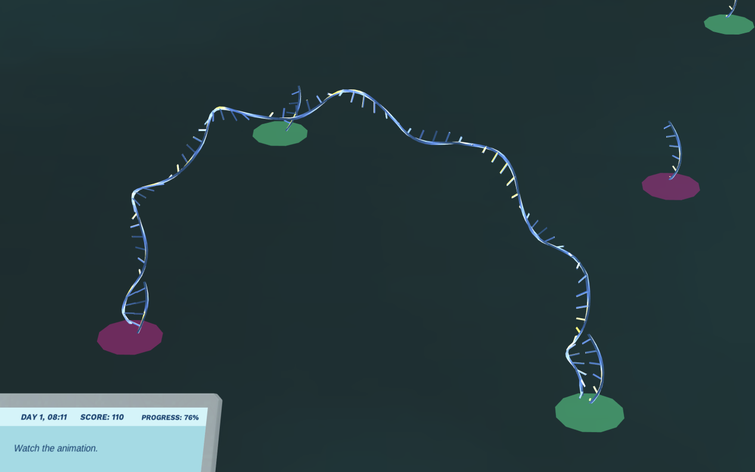

What is currently happening?

Selected option: The DNA molecules are binding to the short DNA molecules on the flowcell

The DNA molecules are now binding with the adapters (the short DNAmolecules) on the flow cell.

How could the DNA molecules bind to the adapter on the flow cell?

Selected option: Because the sequences are complementary

The adapter sequence on the DNA molecules is complementary to the adaptersequence on the flow cell. That is why the two molecules can bind together.

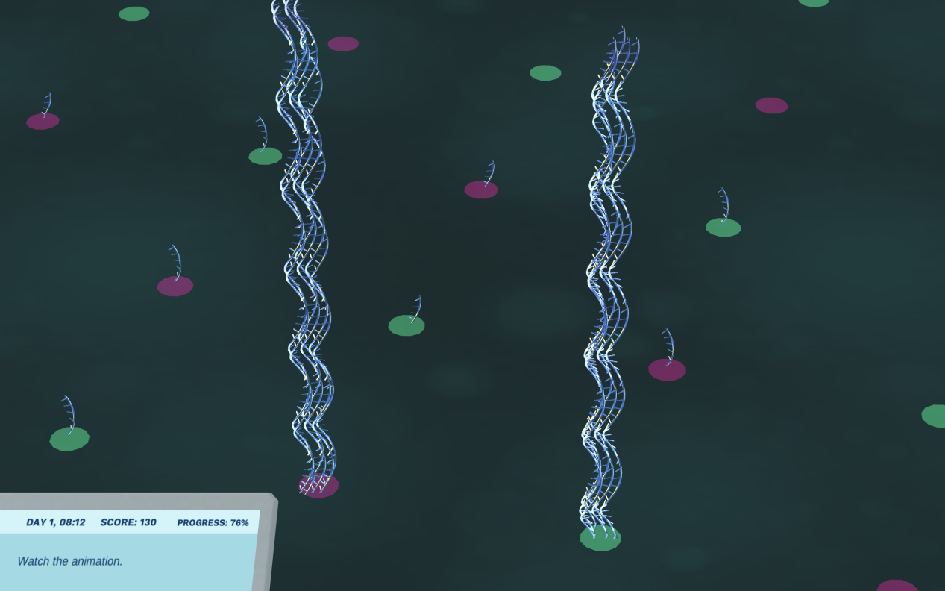

What is the name of the process that is currently shown in the animation, where the DNAmolecules bend and bind each end to an adapter on the flow cell?

Selected option: Bridge PCR

This process is also called bridge PCR, because the DNA molecules bendbinding each end to an adapter on the flow cell and creating a bridge. The DNA moleculesare then amplified, producing many bridges of DNA

How many DNA molecules are produced in each cluster?

Selected option: 4,000

After several rounds of bridge PCR amplification, we get around 4,000DNA molecules in 1 cluster!

After bridge PCR amplification, half of the DNA strands are washed away. Why?

Selected option: To sequence clusters of identical (clona]) DNA

We want to sequence a cluster of clonal DNA, meaning that they need to beidentical. The bridge PCR results in two kinds of DNA molecules, one molecule from 5' to3' and another one from 3' to 5'. By eliminating one molecule type, we can be sure that allof the remaining ones have the same orientation and hence the same sequence.

How many clusters do you think we have in one flow cell?

Selected option: 200 million

in a flow cell, we can have more than 200 million clusters. This means we havearound 200 bilion DNA molecules that are sequenced at the same time! This is why thetechnique is also referred to as massively parallel sequencing.

Which enzyme is used in the sequencing process?

Selected option: T4 DNA polymerase

The T4 DNA polymerase used in the sequencing process is modified to onlyallow incorporation of one base. Then, the process is stopped.

In the next generation sequencing, each of the bases is tagged so that we can specificallyidentify them. What is this tag?

Selected option: Fluorophore

Each of the bases is specifically tagged with a fluorophore. After the base hasattached to the newly buit DNA molecule, a reaction occurs, and the fluorophore wil emitlight with a specific wavelength. The light will be recorded allowing us to identify whether itis A, G,T or C that has just been added.

How many pictures are taken for every single base addition?

Selected option: Four

Each picture records only one specific color. Since we have four bases (fourcolors),we need to take four pictures per round of base addition.

When we are sequencing from only one direction, the process is also called?

Selected option: Single-end sequencing

if we sequence only from one direction, it is called single-end sequencing.Sequencing from both ends is called paired-end sequencing. You can read more aboutsingle- and paired-end sequencing in the 'theory' pages. In this exercise, we areperforming the single-end sequencing

The sequencing outcome is stored, including the sequence and quality. What is this filecalled?

Selected option: FASTO

The FASTQ format is a compact text-based format that has become thestandard for storing data from next-generation sequencing experiments.

In a FASTO file, what is the Phred quality score?

Selected option: The probability of an incorrect base caling for each base

The Phred scale is the probability of an incorrect base caling for each base. lt istypically stored as a ASCll (letter, digit or symbol) character that can be translated into anumber. This number in turn indicates the probability of an indirect base call (1 in n) andthe base call accuracy (%). The purpose of including a tag, also known as a barcode, is toidentify the reads from a specific sample.

The Phred scale describes the probability of the error when calling a base. What is theprobability of an incorrect base call for a quality score of 40?

Selected option: 1 in 10,000

We can interpret the data as we are 99.99% sure that the base is calledcorrectly.

In the secondary data analysis, we assemble all the reads and try to interpret the dataWhat should we do first before starting the secondary analysis?

Selected option: Trim out the adapters

We can continue by trimming out the adapters. They are non-biologicalsequences which are not part of the sample that we are interested in.

Since we are working with ancient DNA, we need to be able to identify whether it hasbeen contaminated with modern human DNA,. Which characteristic below is NOT found inancient DNA?

Selected option: It is structured into very long strands

Because of the age, ancient DNA suffers from post-mortem damages, such asfragmentation, depurination, deamination, nicks and misincorporation.

There are two ways to do an assembly depending if you know the reference sequence ornot. What are they called?

Selected option: Aliqnment and de novo assembly

Alignment is performed when you have a reference genome to compare to, ifnot, then you should perform de novo assembly where you assemble short sequences toreconstruct the complete sequence. Since the human genome has been sequencedalready, we can use it as a reference genome and perform the mapping.

What skin color did the ancient Greenlandic man likely have due to G instead of A in SNPRs1426654?

Selected option: Non-light skin

Rs1426654 A indicates light-skinned European ancestry, but the ancientGreenlandic man has G instead of A. So he does not have light skin.

Which trait is an individual with a G in SNP Rs6152 likely to have?

Selected option: Developing baldness

Rs6152 is located on the androgen receptor on the X chromosome. Havingthe risk allele of G represents the ability to develop male baldness

The ancient Greenlandic man carries two C alleles for Rs1129038. What is the most likelycolor of his eyes?

Selected option: Brown

This SNP is located on chromosome 15. The A allele is very common inindividuals with blue eve color, and the C allele is very common in individuals with browneye color, such as the ancient Greenlandic man.

With the allele of C/C on Rs3827760, what shape were the ancient Greenlandic man's teeth most likely?

Selected option: Shovel-shaped

Rs3827760, which is also known as EDAR 1540C, is strongly associated withindividuals having shovel-shaped teeth.

This man carries two T alleles for Rs17822931, what is the most likely phenotype for this SNP?

Selected option: Dry earwax

The T homozygosity is commonly found in Asians who have dry earwax. ThisSNP is also associated with lipid secretion.

4

How do plants produce molecules like spruceanol?

Selected option: Enzymatic reactions

The spruceanol is produced via enzymatic reactions from a precursor molecule.

These enzymes can be compared to an assembly line in a factory. Every enzyme isanalogous to a machine that converts a molecule into a different metabolite.

We can use bioinformatics to identify the precursor molecule of spruceanol

The Peruvian Rosewood (Micrandra spruceana) plants are rare and not ideal forcultivation. lf we can identify the enzymes that produce spruceanol we can produce thisantimalarial compound in another species that can be efficiently cultivated.

What would you have to insert into the host species to produce spruceanol in largequantities so it can be used as a drug?

Selected option: DNA

lf we can identify and isolate the genes that encode the enzymes needed forspruceanol snthesis we can transform cells from a different species to producespruceanol in large quantities.

Guess how many different Cytochrome P450 genes we can expect in the plant genome!

There are about 250 genes that encode different Cytochrome P450 enzymes in thalecress(Arabidopsis thaliana).

The number is probably similarly high in the Peruvian Rosewood (Micrandra spruceana).

How could you quantify the expression of Cytochrome P450 genes in different tissues?

Selected option: By measuring mRNA levels

We can measure the gene expression and the resulting protein levels byquantifying the mRNA.

Genes in the same gene family have similar sequences. Hence we should be able toidentify the mRNA that encodes the Cytochrome P450 enzymes.

What method could we use to sequence the mRNA of the plant and quantify it at thesame time?

Selected option: RNA-seg

With RNA-seg we can sequence the mRNAs and quantify their expression via thenumber of reads that we obtain for each RNA.

The RNA extract contains different types of RNA. The most abundant RNA in cells areribosomal RNAs(rRNA)

Messenger RNAs (mRNAs) only make up about 5% of all RNA.

All the mRNAs contain a poly Adenine tail which we can target with poly T primers. Thisway we will only reverse transcribe the mRNA.

In order to sequence the mRNA we need to convert it to DNA. What technique could weuse to convert the mRNA into DNA?

Selected option: Reverse transcription

This is correct. We can use the viral enzyme reverse transcriptase to producecomplementary DNA from mRNA.

The resulting DNA is called complementary DNA or cDNA. Compared to the genomic DNAthat is stored in the nucleus of each cell, the cDNA does not contain any introns

Which of these statements is true for cDNA?

Selected option: It contains no introns

The introns are spliced out of the pre-mRNA before it is exported out of thenucleus as mature mRNA. This means our cDNA won't contain any introns.

The NGS workflow requires the use of cDNA reverse transcribed from mRNA. Which stepwould not work with RNA?

Selected option: PCR

The PCR (Polymerase Chain Reaction) uses DNA polymerase to duplicateDNA strands and produce the cluster.

To be able to sequence mRNA, we need to reverse transcribe it into cDNA.

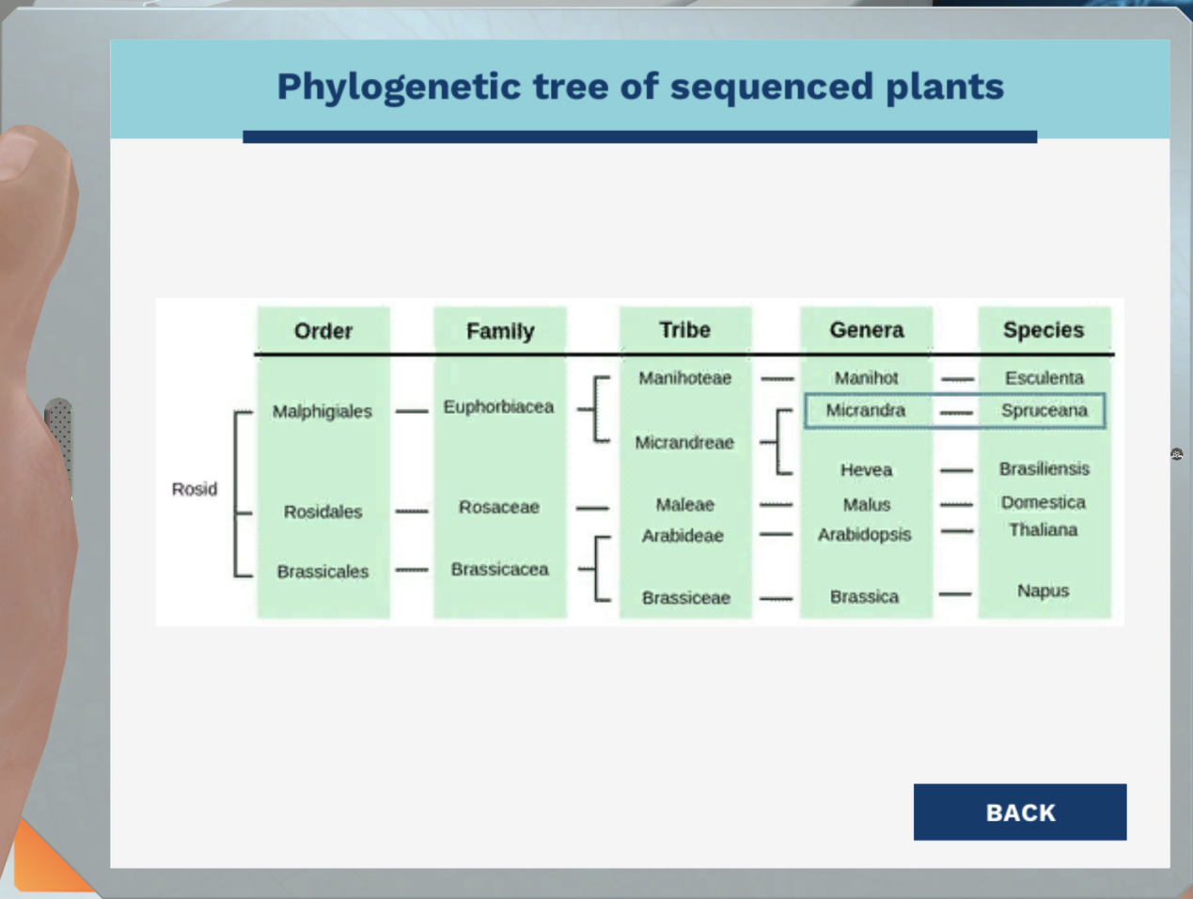

Which genome is best suited to map our sequence reads?

Selected option: Rubber tree (Hevea brasiliensis)

The rubber tree (Hevea brasiliensis) is part of the same tribe as the Peruvian Rosewood (Micrandra spruceana). They are genetically more similar than the other candidatesbecause they share a more recent common ancestor

How could we use this known cytochrome P450 gene to identify other cytochrome P450genes in our Peruvian Rosewood (Micrandra spruceana) sequences?

Selected option: Bysearching for similar sequences

The cytochrome P450 genes are derived from the same ancestral gene. Therefore, theirsequences are homoloqous.

We can identify homologous sequences with an algorithm that aligns all the sequenceswith our query sequence and calculates the similarity. The most commonly used algorithmis called BLAST (Basic Local Alignment Search Tool).

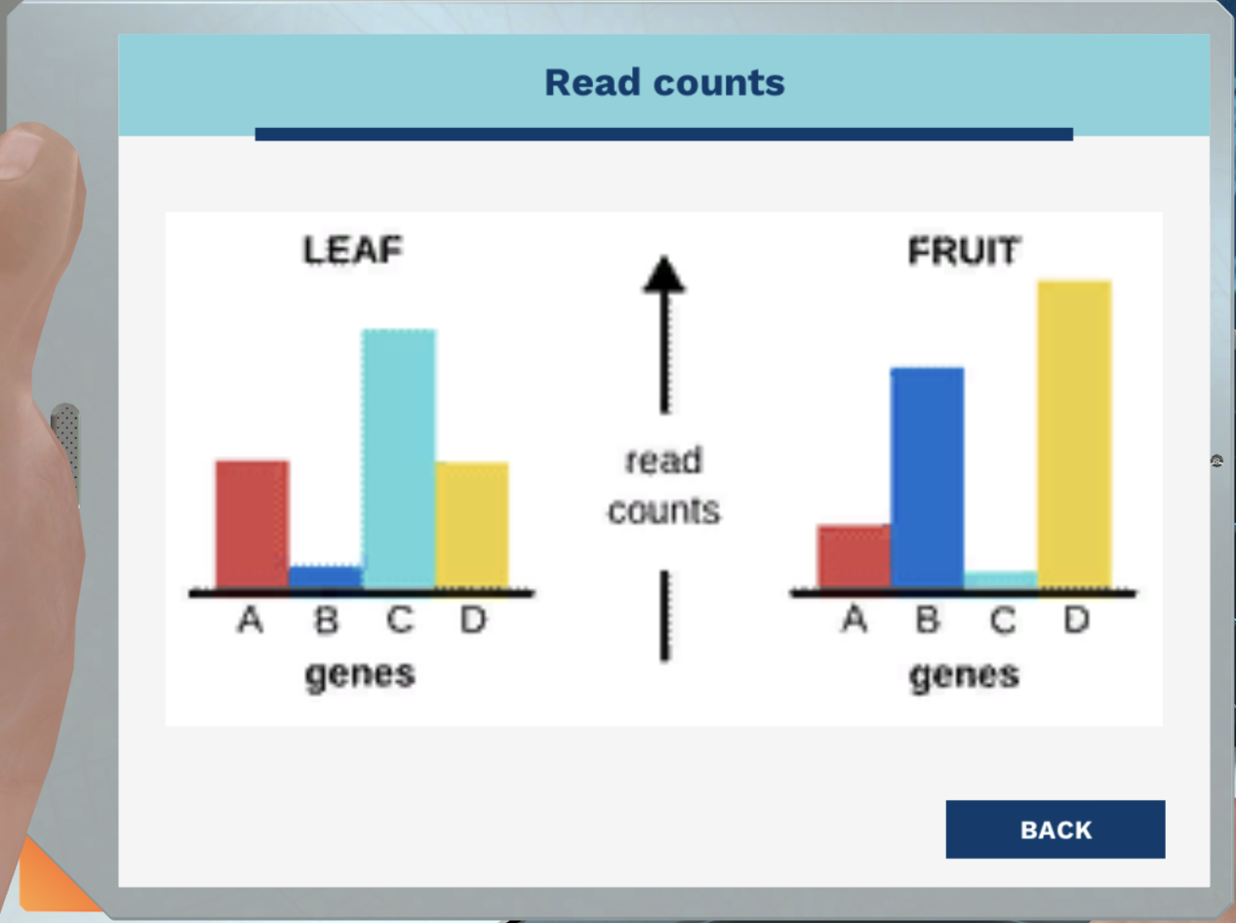

Which one of the following cytochrome P450 enzymes is the most likely candidate forcatalyzing the spruceanol biosynthesis?

Remember there is a lot of spruceanol in the leaves but not in the fruits.

Selected option:C

You found the needle in the haystack!

Why do we need to determine which cell lines produce the highest recombinantFIX?

Selected option: To reduce the cost of hemophilia treatment

By determining which cell line is the most efficient, we will be able to reduce the cost ofrecombinant FlX production. Therefore, lowering the price of hemophilia treatment.

The cell lines produce recombinant FlX and other proteins. Which biomolecule canspecifically detect the presence of a certain protein, such as recombinant FlX, in a samplefull of other proteins?

Selected option: Immunoglobulins

immunoglobulins (lg), also known as antibodies, bind specifically to oneunique protein.

The specificity property of an antibody makes it a very powerful tool in detectingsubstances such as peptides, proteins, hormones, other antibodies and variousbiomolecules.

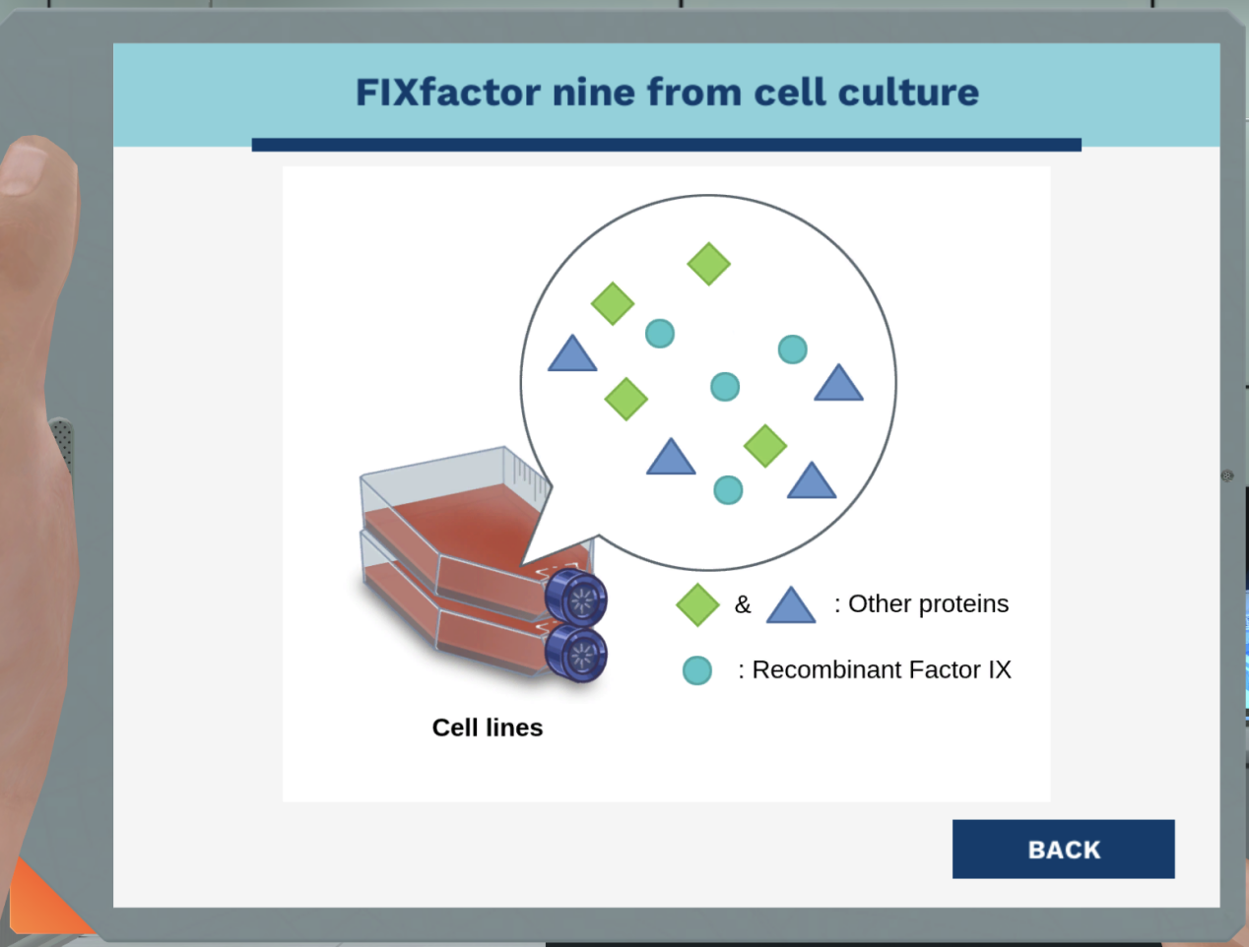

ELISA is a biochemical assay that uses antibodies and an enzyme-mediated colorchange to detect the presence of biomolecules such as proteins, peptides. hormones orantibodies in a sample.

Direct ELISA

Direct ELISA is suitable for determining the amount of high molecular weight antigens.

First, the antigens (red) are coated to the well plate.

The antigen (red) is detected by the antibody (green) that has been directly conjugated toan enzyme (blue).

In a direct ELlSA, which components are directly attached to the plate?

Selected option: Antigens

in a direct ELlSA, antigens are directly attached to the plate by passiveadsorption.

Indirect ELISA

In indirect ELISA, the antigen (red) coated to the well plate is detected in two stages orlayers.

First, unlabeled primary antibodies (green), which are specific to the antigens (red), areapplied.

Next, an enzyme-labeled secondary antibody (dark red) is bound to the first antibody. Thelevel signal resulting from the enzyme activity correlates with the amount of the antigen.

Sandwich ELISA

A sandwich ELISA measures the amount of antigen between two lavers of antibodies(capture and detection antibody). The first antibody (capture antibody) is coated to theplate.

Then, the sample solution that contains the target antigen is added to the well.

Finally, a second antibody (detection antibody) is added, that binds to the antigen in thesample (if any). The antigen to be measured must contain at least two antigenic epitopescapable of binding to both antibodies

If the detection antibody is conjugated to an enzyme (blue), then the assay is called adirect sandwich ELISA (left). lf the detection antibody is unlabeled, then a secondantibody is needed, resulting in an indirect sandwich ELISA (right).

Which component of sandwich ELISA is required in pairs?

Selected option: Antibodies

Sandwich ELISA requires antibody pairs, the capture and detection antibodiesEach antibody is specific for a different part (epitope) on the target protein (antigen).Thisprevents interference of antibody binding.

Competitive ELISA

The most complex ELISA is competitive ELISA. This is common when the antigen is smalland has only one epitope. Here, labeled purified antigen is used. First, the captureantibody is coated to the plate.

Then, the unlabeled antigen (the two antigens on the right) from the sample and thelabeled antigen (the first three antigens on the left) compete for binding to the captureantibody.

If there is a high concentration of antigen in the sample, then there will be a significantreduction in signal from the labeled purified antigen (right). Conversely, if there is littleantigen in the sample, there will be minimal reduction in the signal compared to assaywells with labeled antigen alone (left).

In a competitive ELiSA, how would the signal measured by the detector react to anincrease of antigen in the sample?

Selected option: Decrease

A decrease in signal from purified antigen indicates the presence of the antigen ina sample when compared to assay wells with labeled antigen alone.

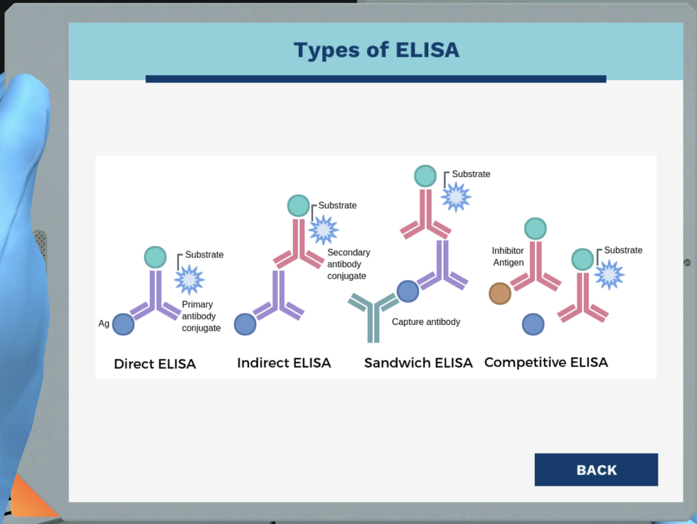

Asking yourself some questions will help you decide which ELiSA type to use.

What do you want to measure?

Amount of Factor IX

We are going to measure the amount of Factor lX, therefore sandwich orcompetitive ELISA is suitable.

If you're going to measure an immunological response, then you should use direct orindirect ELISA.

Now we need to choose between sandwich ELiSA and competitive ELISAWhat is the size of Factor lX?

Large molecule

Factor IX is a protein with multiple binding sites for antibodies (epitope). lt'sconsidered a large molecule. Therefore, a sandwich is suitable.

If you're quantifying a small molecule, such as hapten, competitive ELISA is moreappropriate.

The advantage of sandwich ELISA is that the sample does not have to be purified beforeanalysis, and the assay can be very sensitive.

What are the critical reagents for Factor lX sandwich ELISA?

Anti-FlX antibodyconjugated with HRP(Detection antibody)

Factor IX (FIX)in samples

Anti-FlX antibody(Capture antibody)

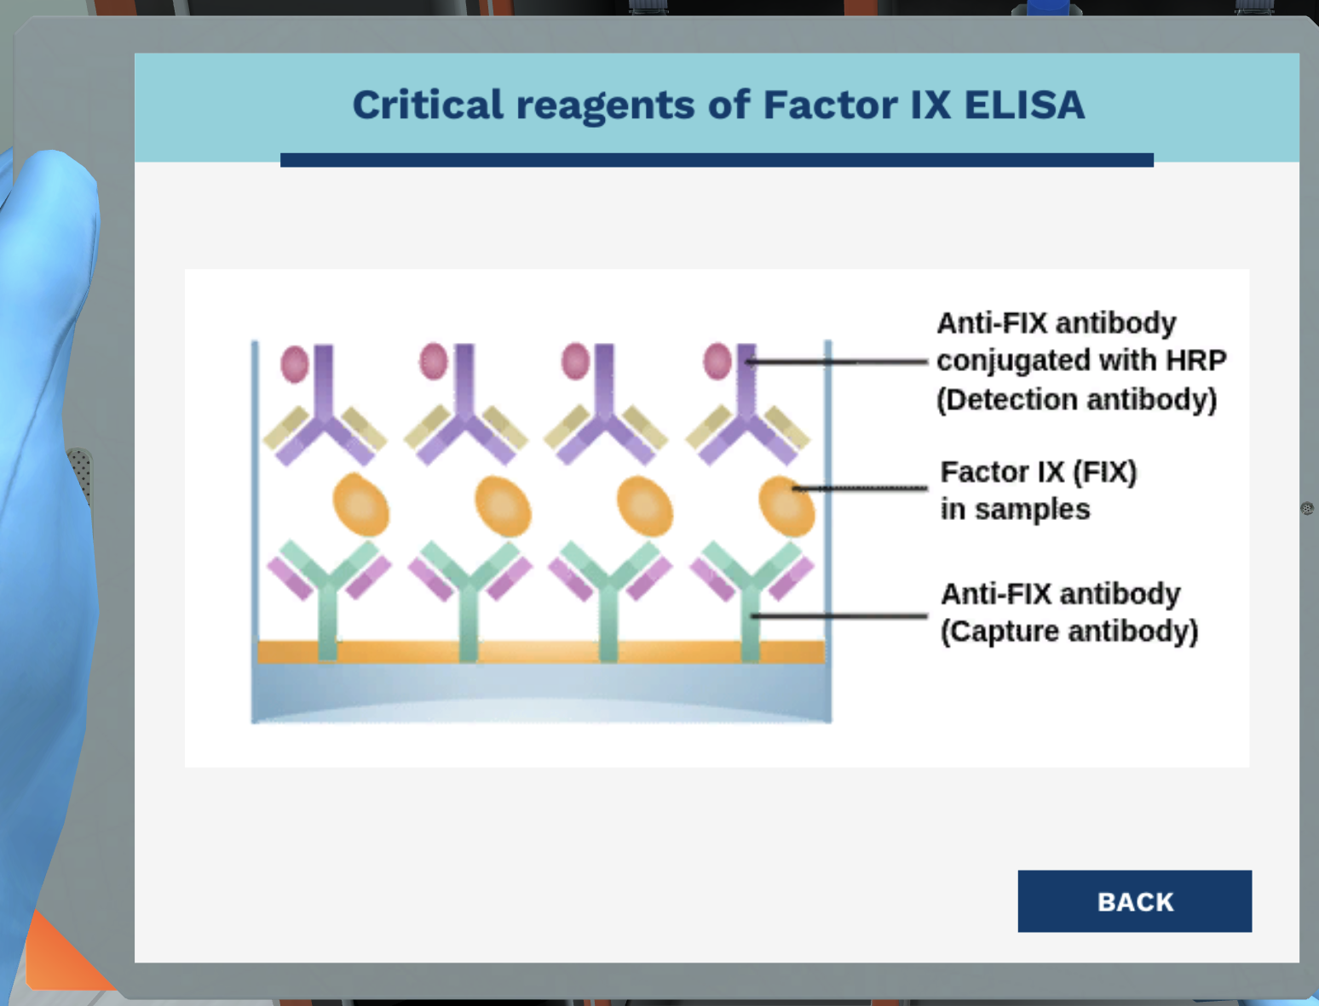

The critical reagents for Factor lX sandwich ELISA are as follows:

1.Anti-FlX(Capture antibody)

2. Factor lX working standard.

3. Anti-FlX antibody conjugated with HRP(Detection antibody)

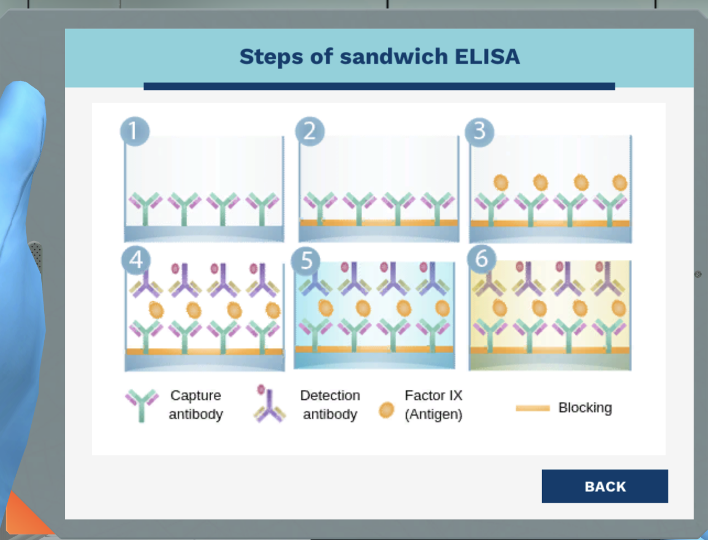

1. Coating.

2.Blocking.

3.Sample dilution.

4.Probing.

5.Detection, start

6. Detection, end.

You are at the first step of FlX sandwich LISA, which allows you to quantitate a specifictarget antigen (Factor lX)from a complex mixture (cell lines samples).

Which antibody do you want to add at this step?

Anti-FlX antibody

The first step of sandwich ELISA is immobilizing capture antibody tothe base of the ELISA well plate. The capture antibody is specific to the antigen. Ourcapture antibody, Anti-FlX, will bind specifically to Factor lX.

In this coating step, the capture antibodies are immobilized on the surface of polystyrenemicroplate wells. What type of force causes the passive adsorption of the capturedantibody due to the interaction between amino acid side chains on the antigen used forcoating, and the plastic surface?

Selected option: Hydrophobic

Passive adsorption is the common technique to attach an antibody or anantiaen to a plate, The adsorntion is mediated by hvdrophobic interactions, The interactiondepends on pH and temperature.

A coating buffer such as carbonate-bicarbonate buffer, Tris-buffered saline (TBS) orphosphate-buffered saline (PBS) are used to facilitate optimum coating conditions.

What are antibodies with high specificity that only detect one epitope called?

Selected option: Monoclona

Monoclonal antibodies, like FlXa, have a high specificity and detect only oneepitope on the antigen. Polvclonal antibodies recoanize multiple epitopes on the antigenand therefore have a higher affinity to the target antigen.

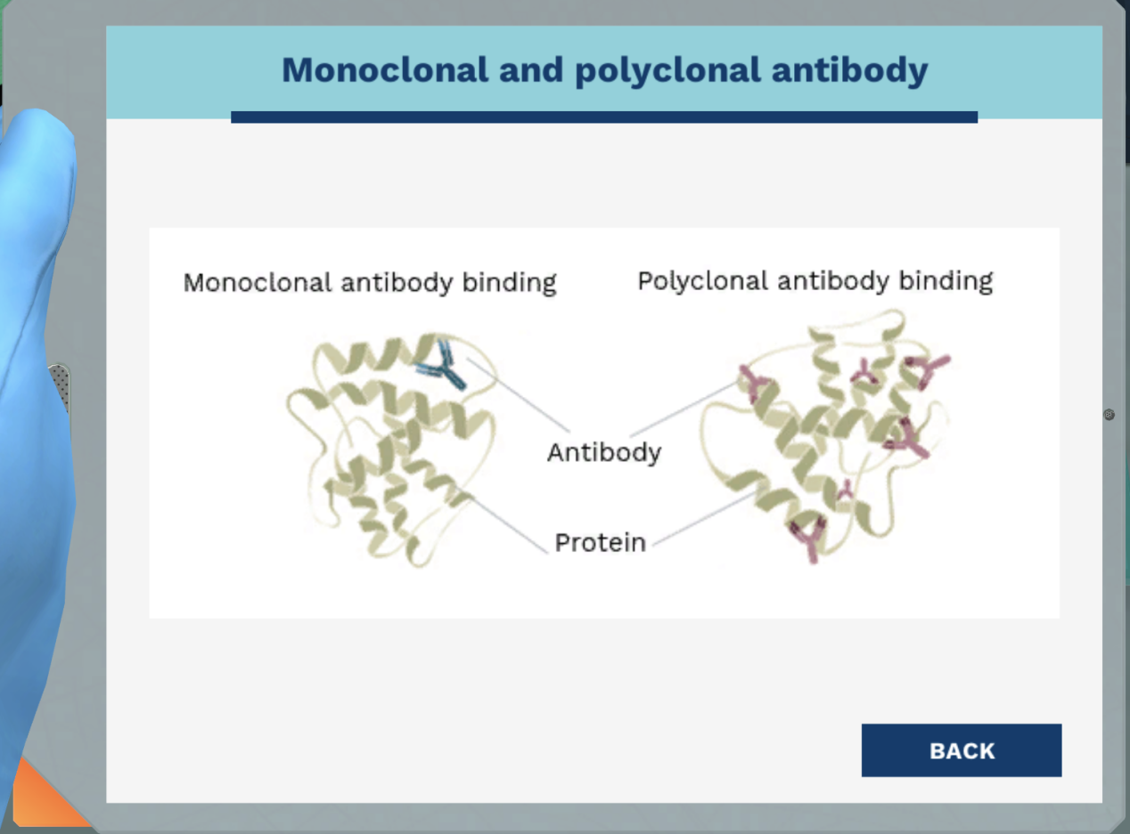

The purpose of blocking buffer is to block all sites that are unbound by the capture antibody. Therefore, no other proteins are able to bind to the plate and create false positives.

The basic blocking buffer contains 5% Bovine serum albumin (BSA) dissolved in PBSWhat is the purpose of adding a blocking buffer?

Selected option: To reduce ELISA background signa!

Blocking buffers usually consist of an unrelated protein or a protein derivative thatdoes not react with any of the antibodies being used in the detection step.

Blocking is necessary to prevent nonspecific binding of proteins to the plate. An optimalblocking buffer maximizes the sianal-to-noise ratio and reduces ELlSA background sianal

Tween 20 is used in our wash buffer. What type of compound is Tween 20?

Selected option: Surfactant

A surfactant such as Tween-20, a gentle non-ionic detergent is added in blockingand wash buffer.

Surfactants can help minimize hydrophobic interactions between the blocking protein(s)and the antigen or the antibodies.

The washing step is paramount for removing any unbound material that may obstruct thebinding of other critical reagent

Why do we have to load the samples into specific wells?

Selected option: To achieve valid results

Performing ELISA requires patience and high attention to details. Each well has adifferent designation. By following the ELISA plate layout, we ensure valid results andmake the consequent data analysis easier

What is the purpose of a standard?

Selected option: To create a standard curve

The standard curve is prepared by making serial dilutions of one knownconcentration of the analyte (standard) across a range of concentrations near theexpected unknown concentration. The concentration of unknown samples is determinedby interpolation which relies on a properly generated standard curve.

The first well contains 200 yL of standard with a concentration of 90 ng/mL. lf we want touse a dilution with 1:2 dilution factor, how much sample should be transferred from thefirst well to the second well that contains 100 uL diluent?

Selected option: 100 μL

The dilution that we want to achieve is 1:2. The initial volume of sample(standard)is 200 uL, therefore the aliquot volume is 100 uL.

We will perform serial dilution with a 1:2 dilution factor. The concentration of the standardin the first well is 90 ng/mL. The aliquot volume is 100 uL. The volume of diluent in well 2.8 is 100 uL each. What is the concentration of the standard in well 8? Take into accountthat we are diluting the concentration to half in each step.

Selected option: 0.7 ng/uL

The concentration of standard is half of the previous well because we areusing serial dilution with 1:2 dilution factor. Therefore the concentration of each well is asfollows:

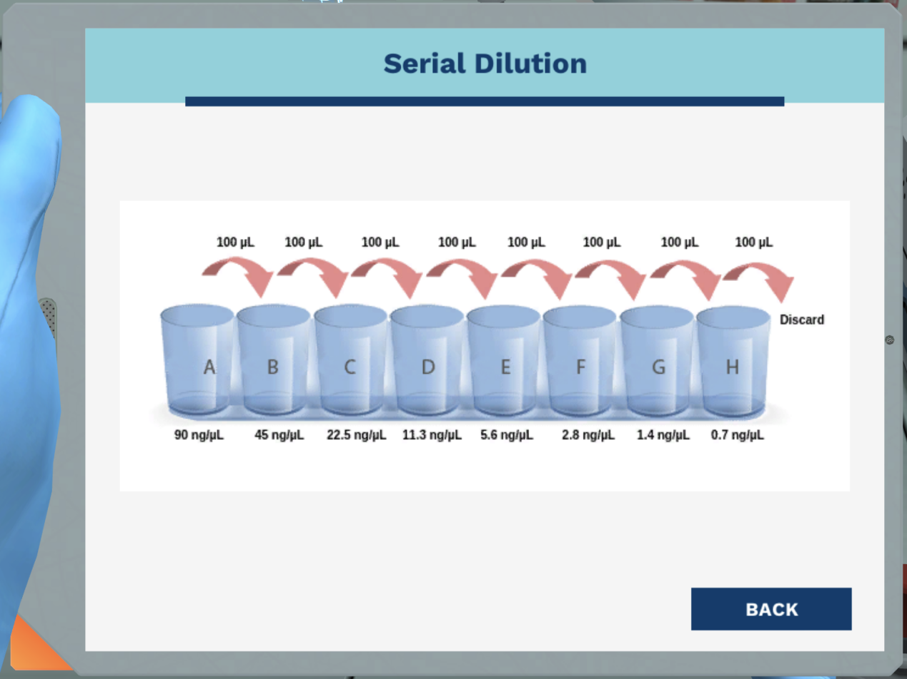

A positive control is a sample known to give positive results for the given test. What is the purpose of a positive control?

Selected option: Verify that the negative results are valid

Controls are needed to make sure the assay is working correctly. A positiveresult from the positive control, even if the samples are negative, will indicate theprocedure is optimized and working.

It will verify that any negative results are valid. lf there is no positive control and thesample is negative, we can't know is the sample was truly negative or if the assay didn'twork.

What is a group of samples where no response is expected called? This group contains albuffers and reagents except the substance of interest.

Selected option: Negative contro!

The negative control is essential to check for nonspecific binding andfalse positive results.

What is the purpose of agitating the ELISA plate?

Selected option: Increasing the rate of binding

Agitating the plate during incubation can significantly accelerate the rate ofbinding. Speeds greater than 600 rpm have a risk of spilling liquid from well to well.

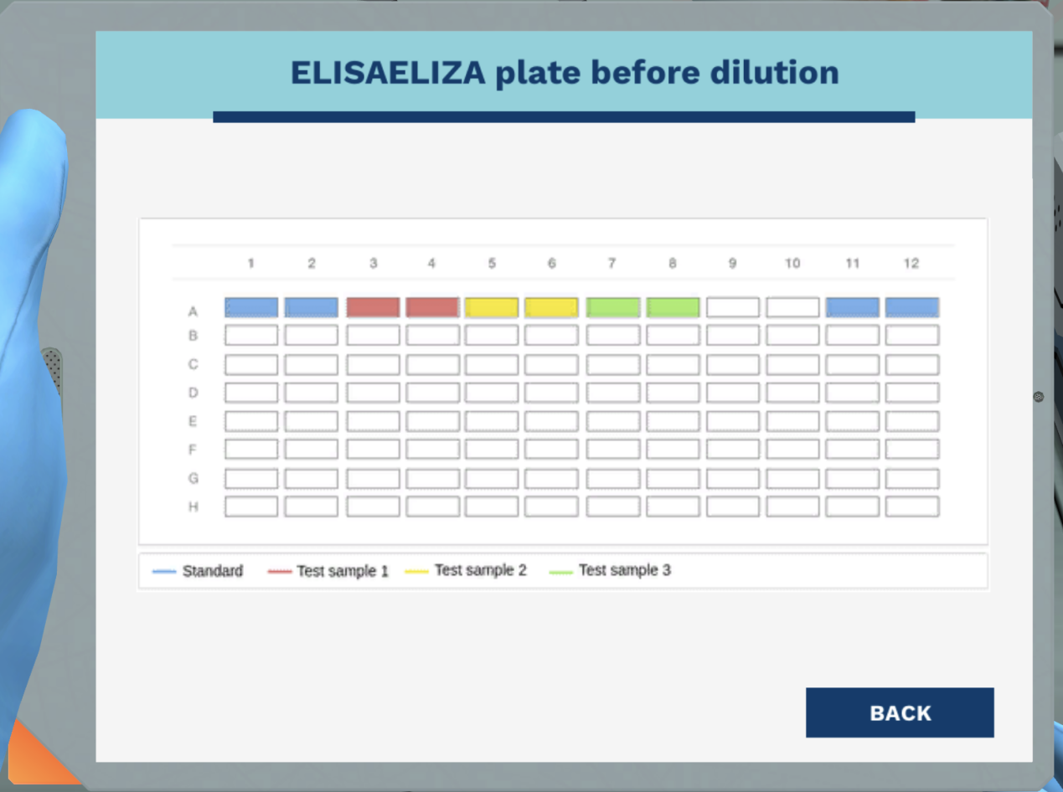

Do you want to measure the amount of Factor lX now?

No,I think we're missing something

Genius! We're indeed missing one more step. Which step do we have to do next?

Selected option: Adding TMB substrate

The final stage is detection.

The detection in ELiSA assay relies on chemical reaction between an enzyme and asubstrate.

The enzyme (HRP) is conjugated with the detection antibody. Therefore, we just have toadd the substrate (TMB) to begin the detection stage.

In the detection stage of ELISA, the enzyme (HRP) converts the substrate (TMB) into adetectable product. in this case, the product exhibit blue color, the intensity of the bluecolor is proportional to the amount of antigen in the sample.

TMB (tetramethyl benzene) is a substrate for horseradish peroxidase (HRP). What is theproper container for storing TMB?

Selected option: Light protected container

TMB is a very light-sensitive substrate and should be protected from directsunlight or UV sources. TMB should be stored at 2°C to 8°C. As some metal ions canoxidize TMB, you should only allow glass or plastic to come in contact with the substrate

Horseradish peroxidase (HRP) catalyzes the reduction of hydrogen peroxide (H,O,) towater (H,O). In the presence of TMB, which act as hydrogen donors, the action of HRPconverts colorless TMB molecules into blue.

A stop solution is added to provide a fixed end point for the assay. What is the stopsolution for the ELISA substrate TMB in the presence of horseradish peroxidase (HRP)?

Selected option: Sulfuric acid

A stop solution stabilizes the color development to enable accurate measurement of theintensity. In the ELISA substrate TMB in the presence of horseradish peroxidase (HRP)sulfuric acid acts as stop solution and changes the solution color from blue to yellow.

We have performed Factor lX Sandwich ELISA. First, theplate is coated with Anti-FlX antibody(green).

Then, blocking is performed with 5% BSA in PBS. Unbound material is removed by asubsequent wash.

The Factor lX standard, control, and sample (yellow) is added. Remember that thestandards, controls, and samples are added in different wells.

The Anti-FlX antibody (red) conjugated with HRP (dark blue) is added to assistdetection. This detection antibody will bind specifically to the Factor lX (yellow).

The amount of bound HRP is detected by adding TMB/H,O, reagent. A higher signalgenerated from HRP enzyme and TMB substrate correlates with a higher amount of FlXin the samples.

Addition of sulfuric acid stops the reaction after 10 minutes, turns the color from blue toyellow, and increases the absorbance two-fold, which is measured photometrically. Thecolor intensity is proportional to the amount of FlX in the samples, which is determined

against the FlX standard.

In the final Factor IX Sandwich ELISA reagents configuration, antigen is bound to thecapture antibody which is attached to the well. The HRP-conjugated detection antibodythen binds to the antigen.

Lower your LabPad and take a look at the PC screen again to explore the graph.A regression formula is obtained from the standard curve. This formula describes therelationship between concentration and absorbance data. We can use this regressionformula to calculate the concentration of unknown samples. in this case, which regressiontype best describes our absorbance data?

Selected option: Log-/0g

The R²should be 0.99 or higher. lf you don't log the transformation of the data, the valuesthat are represented at the low end of vour curve will not be as reliable as the values atthe higher end of your curve. For ELISA data, it is best to use log-log fit.

The equation of the standard curve is y= 0.9988x - 1.437. In ELISA we measured theabsorbance using a spectrophotometer. How can we calculate the amount of Factor lX(FIX) in each sample?

Selected option: Amount of FlX=(Absorbance + 1.437)/0.9988

Genius! The standard curve from the data produced from the serial dilutions with theamount of FlX on the x axis (log scale) vs absorbance on the Y axis (linear). Therefore:

y=0.9988x-1.437

means

Amount of FlX=(Absorbance + 1.437)/0.9988

From: Ms. Stauffer.

Hello, l need your help for troubleshooting. My ELISA result looks weird. Click "Viewlmage' to see it.

All wells exhibit similar bright blue colors, even the negative control. What kind of problemdo l have?

Selected option: You have high background

In ELISA, high background means excessive color development that causes highoptical readings.

High background is usually caused by insufficient washing, using the wrong blocking orstop buffer or a non-specific binding of the antibody.

From:Senor Guzman.

Hi! | have generated the standard curve for my ELISA experiment. Click "View lmage' tosee it. What do you think?

Selected option: Your standard curve is poor

You're correct! The ELISA standard curve is poor. A standard curve is prepared todetermine the concentration of the test samples. The R? of the trend line should be 0.99or higher to ensure accurate results.

This standard curve doesn't look good. This may happen because you are not performingthe serial dilution correctly or you're using expired reagents.

Alright! Marie has completed the remaining parts of the data analysis. The averageabsorbance of each sample are as follows:

Human kidney cell lines(Test sample 1):8.2Human hepatic cell lines (Test sample 2):5.7Human pancreatic cell lines (Test sample 3): 3.6

Which cell lines produce the highest amount of recombinant FlX?

Selected option: Human kidney cell lines

From the ELISA standard curve that you made, we can interpolate theamount of recombinant FlX with absorbance.

Amount of FlX =(Absorbance + 1.437)/0.9988

The higher the absorbance, the higher the amount of FlX will be. Human kidney cell linesproduce the highest amount of FlX.

6

Today we will try to detect two of them - lgG andgM. Both antibodies are produced by B cells upon infection. Their role is to identify andneutralize harmful substances or pathogens

When a patient has an infection, lgM is one of the first antibodies produced. Afterinfection, the plasma cells provide antibody-mediated protection by producing lgGantibody long term.

We can use this pattern of production as a diagnostic test to confirm if a patient has acurrent infection or has ever been exposed to a particular pathogen.

If a person has previously received a vaccine to a particular disease and currently is notinfected with it, what pattern of antibodies would we expect to see in their blood serum?

Selected option: There would be pathogen reactive lgG in the blood, but not much lgM

The only reason we might not see this pattern is if a person was unable toproduce lgG to the pathogen, like how some people don't become immune to chickenpoxafter their first infection or vaccine as a child.

OK! Let's get started. l'l talk you through the process as we go.

Which antibody accounts for 80% of all circulating antibody molecules in a human body?

Selected option: /gG

IgG is the most abundant type of antibody in humans. lt circulates freely in the bloodplasma and signals the immune response once it binds to invading pathogen and otherforeign antigens.

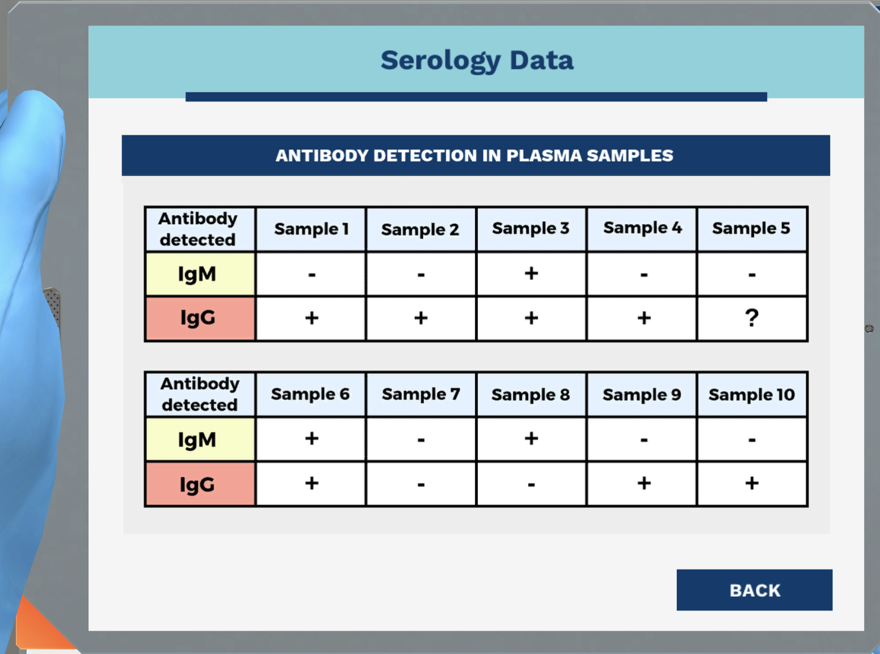

How many of these patients have either been exposed to the disease previously or havereceived a vaccine?

Selected option: 7

We're looking for samples with detectable lgG levels. it looks like oneof the samples was a little ambiguous, we can't be certain of the lgG status there.

Are any of the patients potentially suffering from a current infection?

Selected option: Yes, the patients who gave samples 3, 6 and 8

The fact that we can detect disease reactive lgM in these samples is highly suggestive ofinfection there, l agree. Nice identification.

Should any of these samples be retested?

Selected option: Yes, samples 8 and 5

Sample 8 might be a very recent infection, it would be a good idea to retestthis patient in a few days to confirm the infection. Sample 5 seems to be ambiguous,maybe something went wrong with our procedure. l can repeat it later just to be sure ofthe lgG status.